Book

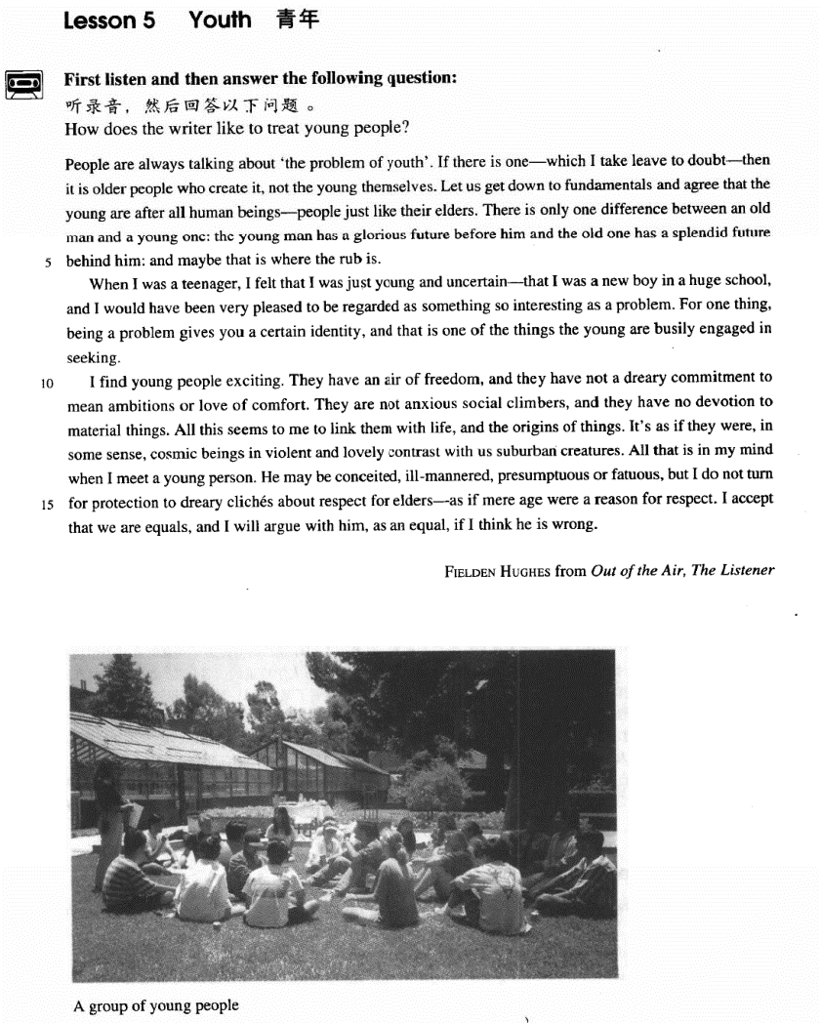

课文

People are always talking about 'the problem of youth'.

人们总是在谈论“青年问题”。

If there is one -- which I take leave to doubt -- then it is older people who create it, not the young themselves.

如果这个问题存在的话 -- 请允许我对此持怀疑态度 -- 那么，这个问题是由老年人而不是青年人造成的。

Let us get down to fundamentals and agree that the young are after all human beings -- people just like their elders.

让我们来认真研究一些基本事实：承认青年人和他们的长辈一样也是人。

There is only one difference between an old man and a young one:

老年人和青年人只有一个区别：

the young man has a glorious future before him and the old one has a splendid future behind him: and maybe that is where the rub is.

青年人有光辉灿烂的前景，而老年人的辉煌已成为过去。问题的症结恐怕就在这里。

When I was a teenager, I felt that I was just young and uncertain -- that I was a new boy in a huge school,

我十几岁时，总感到自己年轻，有些事拿不准 -- 我是一所大学里的一名新生，

and I would have been very pleased to be regarded as something so interesting as a problem.

如果我当时真的被看成像一个问题那样有趣，我会感到很得意的。

For one thing, being a problem gives you a certain identity, and that is one of the things the young are busily engaged in seeking.

因为这至少使我得到了某种承认，这正是年轻人所热衷追求的。

I find young people exciting.

我觉得年轻人令人振奋，

They have an air of freedom, and they have not a dreary commitment to mean ambitions or love of comfort.

他们无拘无束。既不追逐卑鄙的名利，也不贪图生活的舒适。

They are not anxious social climbers, and they have no devotion to material things.

他们不热衷于向上爬，也不一味追求物质享受。

All this seems to me to link them with life and the origins of things.

在我看来，所有这些使他们与生命和万物之源联系在了一起。

It's as if they were in some sense cosmic beings in violent and lovely contrast with us suburban creatures.

从某种意义上讲，他们似乎是宇宙人，同我们这些凡夫俗子形成了强烈而鲜明的对照。

All that is in my mind when I meet a young person.

每逢我遇到年轻人，脑子里就想到

He may be conceited, ill-mannered, presumptuous or fatuous, but I do not turn for protection to dreary cliches about respect for elders -- as if mere age were a reason for respect.

这些年轻人也许狂妄自负，举止无理，傲慢放肆，愚昧无知，但我不会用应当尊重长者这一套陈词滥调来为我自己辨护，似乎年长就是受人尊敬的理由。

I accept that we are equals, and I will argue with him, as an equal, if I think he is wrong.

我认为我和他们是平等的。如果我认为他们错了，我就以平等的身份和他们争个明白。

词汇讲解

**Lesson 5 Youth** leave [li:v]

n. 允许，许可

leave n. permission 允许，许可

He did it without my leave.

The senator asked leave to take the floor. I take leave to do sth.

I take leave to say / doubt / think … forgive me for doing

Forgive me for saying so, but what you said is nonsense. I take the liberty of doing

I take the liberty of asking you a question. I venture to do

I venture to say that you are making a dangerous mistake. fundamentals

[7fʌndə'mentlz]

n. 基本原理，基本原则

fundamentals n. basic rules, ideas or principles 基本原理，基本原则

the fundamentals of philosophy / economics

the basics the rudiments the first principles

fundamental adj. basic, essential 根本的

the fundamental difference

the fundamental cause of the problem glorious ['ɡlɔ:riəs]

adj. 光辉灿烂的，荣耀的，辉煌的

a glorious achievement

All the Chinese compatriots should take concerted efforts to create a glorious future of the Chinese nation.

a rosy / brilliant / splendid / magnificent future glory

glory days rub [rʌb]

n. 难题，困难，困境

rub n. a problem or difficult situation 难题，困难，困境

Here is the rub.

That’s where the rub is. rub sb. the wrong way

She has a negative impression of him.

She sees nothing new about him.

She thinks he gave her the wrong directions.

She doesn’t know him as well as she would like to.

M: what do you think of our new economics instructor?

W: I don’t know. Something about him rubs me the wrong way. Q: what does the woman say about the instructor?

Answer: (A) She has a negative impression of him. rub sb. the wrong way

get on one’s nerves

The man shouldn't have invited her roommate to the meeting.

Her roommate was unable to attend the meeting.

Her roommate is unreliable about delivering messages.

She forgot about the time change.

M: Why did you come to the meeting late? I left a massage with your roommate about the time change.

W: She has a very short memory and it really gets on my nerves sometimes.

Q: What does the woman imply?

Answer: (C) Her roommate is unreliable about delivering messages. commitment [kə'mɪtmənt]

n. 信奉，信仰；承诺

commitment *to* sth.

have a sincere commitment *to* religion / communism

*make* a commitment to do …

She promised to stand by him, and once you make that commitment you have to see it through.

*honor / fulfill* one’s commitment

We must *honor* our commitments *to* small nations.

The President of the United States has reiterated the U.S. commitment *to*

the Three Sino-U.S. Joint Communiqués . devotion [dɪ'vəʊʃn]

n. 热爱

devotion *to* sb. / sth.

devotion *to* the cause of education love

affection parental affection maternal / paternal affection affectionate

infatuation

Their infatuation with each other won’t last. cosmic ['kɒzmɪk]

adj. 宇宙的

cosmos comic comet

cosmetics make-up

She doesn’t wear make-up. √ She doesn’t wear cosmetics. X

universal

Certain funny situations have a universal appeal.

suburban [sə'bɜ:bən]

adj. 郊区的；见识不广的，偏狭的

suburban provincial

rural pastoral suburban urban

metropolitan metropolis

cosmopolitan cosmopolis be always doing

He’s always having arguments with people.

Our vicar is always raising money for one cause or another, but he has never managed to get enough money to have the church clock repaired.

The woman would understand if she did Mary’s job.

The woman should do the typing for Mary.

The woman should work as hard as Mary.

The woman isn’t a skillful typist.

W: Mary is always complaining about her job.

M: Maybe if you try typing letters every day, you'd see what it's like. Q: What does the man mean?

Answer: (A) The woman would understand if she did Mary’s job.

be forever doing

He is forever talking about the friendly people, the clean atmosphere, the closeness to nature and gentle pace of living.

be constantly / continually doing sth.

Your behavior reflects on me, and I can't do my job if you're constantly humiliating me.

Constantly? Aside from today, give me one example.

keep (on) doing sth.

From the moment he arrived there, he kept on pestering his doctor to tell him when he would be able to go home.

In the process, he enjoyed himself thoroughly and kept telling everybody how much he hated hospitals.

do sth. all the time / time and time again / with monotonous regularity / ad nauseam

The same old favorites recur year in year out with monotonous regularity.

He is tired of waiting for assistance.

He doesn't have to ask his friends for help.

His foot hurts too much to walk.

He doesn't like to bother people.

W: I thought the doctor said you should stay off your foot until the swelling goes down.

M: She did. It just makes me uncomfortable to ask my friends to wait on me all the time.

What does the man mean?

Answer: (D) He doesn't like to bother people.

If there is one*—which I take leave to doubt—*then it is older people who

create it, not the young themselves. at all

Do you know him at all?

He will come before dinner if he comes at all.

If there is one at all, then it is older people who create it, not the young themselves.

it is / was … that / who …

If …… —which I take leave to doubt—then it is … that / who …, not … 造句: 如果真有天堂的话（请允许我对此表示怀疑），那么也是有钱有势的人（the rich and powerful）去的地方, 而不是穷人自己可以去

的地方。

If there is heaven—which I take leave to doubt—then it is the rich and powerful who can enter, not the poor themselves.

Let us get down to fundamentals and agree that the young are after all

human beings—*people just like their elders*. get down to sth. / doing

to start doing sth. seriously Let’s get down to business.

Let’s get down to discussing the details.

agree v. accept / admit / acknowledge / recognize / concede

All these countries recognize / concede that there is only one China. There is only one difference between an old man and a young one: the

young man has a glorious future before him and the old one has a

splendid future behind him: and maybe that is *where the rub is*. just / merely / no more than one difference

a single / solitary difference antithesis 对比

When poverty comes in at the door, *love leaps out at the window*.

A mother takes twenty years to make a man of her boy, and *another*

*woman takes twenty minutes to make a fool of him*.

谦受益 满招损

人有悲欢离合 月有阴晴圆缺卑鄙是卑鄙者的通行证

高尚是高尚者的墓志铭文竹 武松

孙行者 祖冲之

三星白兰地 五月黄梅天一品天青带 六味地黄丸

That’s where you and I differ. That’s where I draw the line.

When I was a teenager, I felt that I was just young and uncertain—that I

was a new boy in a huge school, and I would have been very pleased to

be regarded as something so interesting as a problem. teenager / teen n.

in one’s teens

When I was in my teens, … adolescent n. & adj.

When I was an adolescent, … my adolescent daughter adolescence n.

juvenile

juvenile delinquency juvenile delinquent

The society is like a huge school. regard / see / count A as B

think of / look on / conceive of A as B

consider A (to be) B

If you lived in the Mediterranean, for instance, you would consider octopus a great delicacy.

deem / reckon A to be B

be recognized / acknowledged as …

Heifetz was recognized / acknowledged as the greatest violinist of the 20th century.

Being a problem is better than being a nobody.

*For one thing*, being a problem gives you a certain identity, and that is one of the things the young are busily engaged in seeking.

for one thing … for another …

"Why won't you come to New York with me?"

"For one thing, I don't like flying, and for another, I can't afford it." on the one hand ... on the other (hand) …

On the one hand I'd like a job which pays more, but on the other (hand) I enjoy the work I'm doing at the moment.

not that …, but that …

Not that I love Caesar less, but that I love Rome more.

— Shakespeare ‘Julius Caesar’

Not that I love you less, but that I love liberty more.

Not that I love my teacher less, but that I love truth more.

It is not that … but (that) …

It was not that I actually remembered anything at all. But my father had described over and over again what we should see at every milestone, after leaving the nearest town, …

It is not that the scales in the one case, and the balance in the other, differ

in the principles of their construction or manner of working; but that the

latter is a much finer apparatus and of course much more accurate in its

measurement than the former.

be engaged in sth. / doing

How many spiders are engaged in this work on our behalf ?

It's as if they were, in some sense, cosmic beings *in violent and lovely*

*contrast with us suburban creatures*. as if … / as though … (虚拟语气)

Don’t act as if you were the only pebble on the beach.

in some sense

I think he may be right in some sense. to some degree / extent

I agree with you to some degree / extent. in some measure

The true value of a human being is determined primarily by the measure and the sense in which he has attained liberation from the self.

Albert Einstein

human being intelligent being alien being

To be, or not to be: that is the question.

William Shakespeare

I think therefore I am.

— René Descartes

*Being and Nothingness*

— Jean Paul Sartre

in / by contrast to / with …

in / by comparison to / with … compared to / with …

be *in* one’s mind be *on* one’s mind

He may be conceited, ill-mannered, presumptuous or fatuous, but I do not turn *for protection* to dreary cliches about respect of elders—*as if mere*

*age were a reason for respect*. ill-mannered

ill-tempered

ill-advised ill-bred

ill-educated

Nor is it only the ignorant and ill-educated person who was such faith in the bottle of medicine.

turn to … for …

The child turned to his mother for comfort.

The refugees turned to the embassy for protection.

He had to turn to his brother for help, because his brother is the only person he could trust.

He had to turn *for help* to his brother, the only person he could trust.

The long hours in the office or the factory bring *with them as their reward*, not only the means of sustenance, but a keen appetite for pleasure even in

its simplest and most modest forms. An idle youth, a needy age.

I accept that we are equals, and I will argue with him, *as an equal*, if I

think he is wrong. Claim-Response Pattern claim

response

reasons for response

relevant example(s) reaffirmation